ABSTRACT

Title:
“A Comparison of BMI, Radiation Time, and Radiation Exposure During Percutaneous Spinal Injection Procedures.”

Authors:
Howard Levy MD, Susan Dreyer MD, Jordan L Tate, MD, MPH, Tanya Cabrita MD, Paul K. White MD

Study Design : A prospective observational single center study involving 324 participants who underwent fluoroscopy-guided percutaneous lumbar spine injection procedures.

Objective: The purpose of this study was to measure radiation exposure during percutaneous spinal procedures using small nanoDot radiation detectors and correlate this with body mass index (BMI) and radiation time.

Background:
Larger body habitus is thought to require higher doses of radiation during radiologic evaluations to obtain the desired image. Obesity has been correlated with increased dose of radiation during fluoroscopy-guided procedures in cardiology interventions. It is unknown what relationship exists between patient body habitus and radiation dose during fluoroscopy-guided percutaneous spine injection procedures.

Methods:
We recorded BMI, radiation time, and radiation exposure in successive participants undergoing lumbar spinal injections at our facility. The day of the procedure the patient’s height and weight were recorded and converted into BMI. Small nanoDot radiation detectors were placed on top of the fluoroscopy table underneath the patient during the spinal injection procedure. The settings on the C-arm for amount of X-ray (MAS), strength of X-ray (kVp) and time of exposure (seconds) were recorded. The amount of radiation exposure was later read using a radiation dosimeter reader and recorded in Grays (Gy).

Results:
226 of 324 patients were overweight or obese (BMI> or equal to 25). The mean radiation exposure was 3.213 Gy and 4.187 Gy for normal weight and overweight/ obese, respectively, with a p-value of 0.16. The mean radiation exposure per second of radiation time was 0.417 Gy/sec and 0.532 Gy/ sec for normal weight and overweight/ obese, respectively, with a p-value of 0.09. Radiation exposure and radiation time were correlated with p-value of <0.0001.

Conclusions:
Radiation exposure during fluoroscopy-guided percutaneous lumbar spine injection procedures is correlated with fluoroscopy time (p<0.0001) but not BMI (p=0.16) in our study population.

Key words: lumbar , spine, epidural , facet injection, body mass index , radiation, fluoroscopy-guided
MANUSCRIPT

Introduction:
Lumbar spine percutaneous injection procedures are commonly performed with fluoroscopic guidance for anatomic localization, to ensure correct needle placement, and to decrease intravascular uptake of medication. The use of fluoroscopy during lumbar epidural corticosteroid injections, facet joint blocks, medial branch blocks, and radiofrequency ablation procedures exposes patients to radiation. It is known that radiation exposure can cause local skin reactions and burns, as well as increase long-term risk for neoplasia. Radiation society recommends minimizing radiation exposure to patients to decrease their risk.
Spine interventionalists using C-arm fluoroscopy will commonly obtain multiple views and implement live time fluoroscopy. These techniques contribute to increased time for radiation exposure. Other factors including operator experience, use of training physicians, have been shown to increase radiation exposureto the patient furing these spine inhection procedures. It has been proposed that patient body habitus may be a factor in length of procedure due to increase need for multiple views, multiple attempts for needle placement etcincreasing the technocal difficulty. Moreover, radiation must penetrate more tissue to obtain images and the increase in depth blah. Obesity has been correlated with increased dose of radiation during fluoroscopy-guided procedures in cardiology interventions. To our knowledge the relationship between BMI and radiation exposure during spinal injection procedures has not been studied. It is unknown what relationship exists between patient body habitus and radiation dose during fluoroscopy-guided percutaneous spine injection procedures.

We aim to investigate the relationship between patient BMI and radiation exposure. NanoDots, Landauer TM, are radiation dosimeters. We utilized these at our facility to measure patient radiation exposure.
Materials and Methods:

This is an observational, prospective, single center study involving 324 patients. The lumbar interventional spine procedures were performed at a teaching hospital in Atlanta, GA between 2010 and 2012 by two attending physicians with the assistance of a fellow or resident physician. There was no exclusion criteria used and all patients (n=324) who underwent fluoroscopy procedures were included in the study. Prior to the procedure, the patient’s height and weight were recorded and converted into Body Mass Index (BMI). The identifying number of the nanoDot (Image 2) and the type of procedure were recorded. Prior to the patient’s procedure, a nanoDot was placed beneath the patient on top of the fluoroscopy table. The settings on the C-arm for amount of X-ray (MAS), strength of X-ray (kVp), time of exposure (seconds) were recorded. Following the procedure, the nanoDot was removed and placed in a sealed envelope. Then each individual nanoDot was scanned, and placed in the calibrated Microstar© Dosimeter (Image 1). The radiation exposure was read and recorded in Grays (Gy).

STATISTICAL ANAYLYSIS

The data was analyzed into two separate studies. The studies included 324 patients which were separated out into normal BMI < 25 (n=98) and non-normal BMI ≥ 25 (n=226). In the first study the BMI groups were compared to the amount of radiation exposure the patient encountered. In the second study the BMI was compared to both radiation time and radiation exposure in all participants.
Results:

In the first comparison (Table 1), radiation exposure was compared to both normal BMI (N=98) and non-normal BMI (N=226). In the normal BMI group he lower 95% confidence interval for the mean was 2.222565 and the upper 95% confidence interval was 4.202923. The non-normal BMI group had a lower 95% CL of 3.246648 and an upper 95% CL of 5.128499. There is no significant difference of radiation exposure between normal BMI and non-normal BMI (p=0.16 using the WMW test).

Similarly, there was no significant difference for RAD exposure per RAD time (Gy/sec) when comparing normal BMI vs non-normal BMI (p=0.09 from WMW test). In the normal BMI group, the GY/RAD mean was 0.417078, while in the non-normal BMI group, the GY/RAD mean was 0.531908.

The correlation between BMI, RAD time, RAD exposure was also analyzed. (Table 3), The Spearman correlation coefficient between RAD time and RAD exposure was 0.39(p<0.0001). There was no correlation found between BMI and RAD time (ρ=0.07) and between BMI and RAD exposure (ρ=0.11). The mean BMI was29.0, the mean RAD time was 16.7sec, and the mean RAD exposure was 3.89272GY.
Discussion:

Radiation exposure during interventional spine procedures is correlated with fluoroscopy time (p<0.0001) Table 3. The relationship between BMI and radiation exposure need further study (ρ=0.11 and p=0.0550) by increasing the power of the statistical analysis.

References:
Tables:

GY = RAD Exposure (grays)
RAD = RAD Time (sec)
BMI = Body Mass Index
Normal BMI <25
Non-Normal BMI ≥25

Table 1
Test RAD Exposure between BMI Normal/non-Normal: p=0.16 (Wilcoxon-Mann-Whitney test). Test RAD Exposure/RAD Time between BMI Normal/non-Normal: p=0.09 (Wilcoxon-Mann-Whitney test).
BMI | N | Variable | N | Mean | Std Dev | Median | Lower 95%  CL for Mean | Upper 95%  CL for Mean
<25 | 98
  GY
  GY/RAD
  98
  98
  3.212744
  0.417078
  4.938859
  1.571180
  0.775843
  0.060802
  2.222565
  0.102077
  4.202923
  0.732080
≥25 | 226
  GY
  GY/RAD
  226
  226
  4.187573
  0.531908
  7.178257
  1.990985
  1.269166
  0.084457
  3.246648
  0.270930
  5.128499
  0.792886

Table 2 Correlation between BMI RAD Time, and RAD Exposure
Simple Statistics
Variable | N | Mean | Std Dev | Median | Minimum | Maximum
BMI | 324 | 28.99537 | 6.25747 | 28.10000 | 18.00000 | 51.50000
RAD Time (sec) | 324 | 16.73290 | 11.26261 | 14.00000 | 0.05000 | 81.00000
RAD Exposure (GY) | 324 | 3.89272 | 6.58939 | 1.05594 | 0.04924 | 49.38342

Table 3 Spearman Correlation Coefficients, N = 324, Prob > |r| under H0: Rho=0
 | BMI | RAD Time | GY
  BMI
  1.00000
  0.06653(p=0.2324)
  0.10672(p=0.0550)
  RAD Time (sec)
  0.06653(p=0.2324)
  1.00000
  0.38576(p<0.0001)
  RAD Exposure (GY)
  0.10672(p=0.0550)
  0.38576(p<0.0001)
  1.00000

- the analysis.

- ANOVA analysis:

From ANOVA, “RAD Time” is the only factor that is statistically significant

Images:
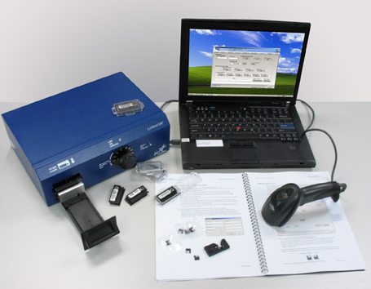
IMAGE 1
- 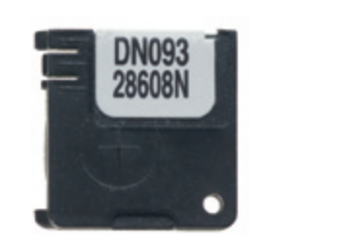

IMAGE 2
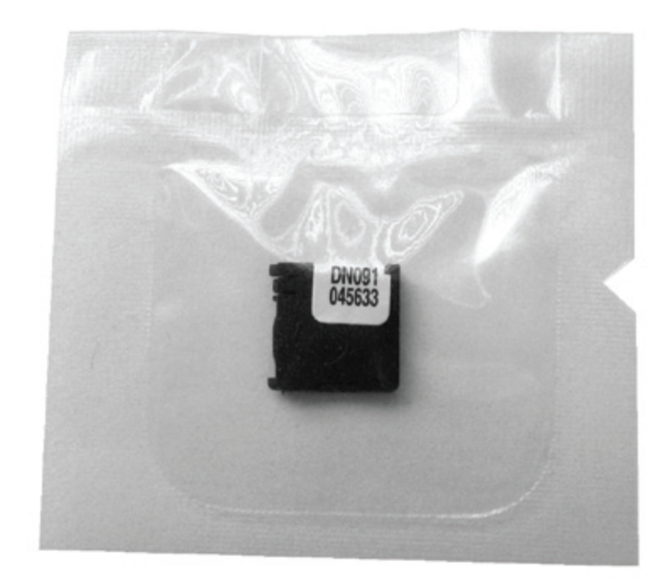
IMAGE 3
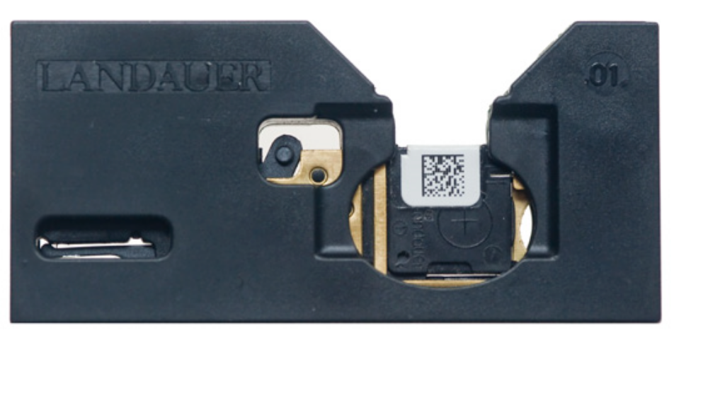
IMAGE 4
IMAGE 5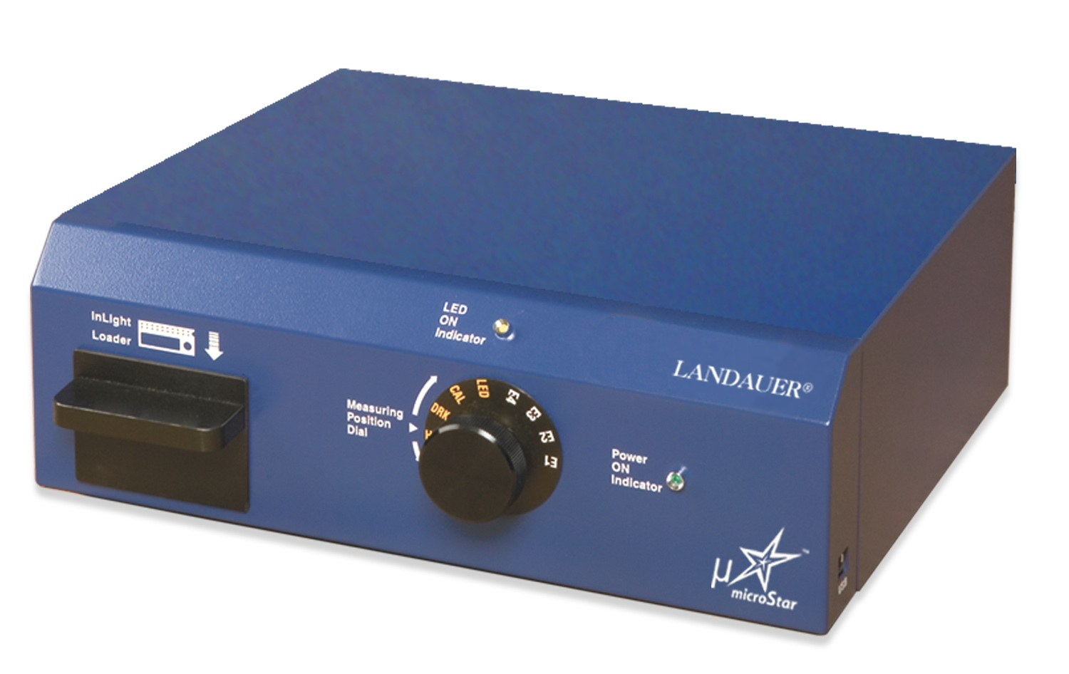
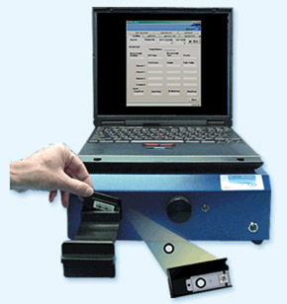
IMAGE 6
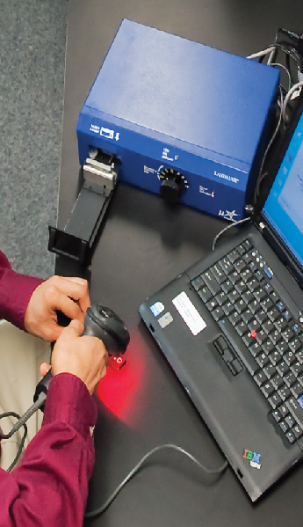
IMAGE 7

